**Predicting the Academic Performance of Tehran University Students with Supervised Algorithms and Comparing it with the Results of Previous Studies**

**Abstract**

Students' GPA is an essential factor in identifying students' academic performance. Therefore, analyzing the factors that predict students' GPAs is crucial. Today, with the development of artificial intelligence analysis, the importance of applying these tools has been doubled due to their ability to predict accurately. According to this, the aim of this research is to predict the academic performance of Tehran University students with supervised algorithms and compare it with previous studies' results. Therefore, the data of Tehran University students in the period (2016-2021) was collected by the whole census method in 14 faculties. Supervised learning algorithms used in the research include: linear regression, Neural network regression (Neural Network optimized), Random forest (Random Forest optimized) and Decision Tree. Among the models, the best value RMSE (1.53) was related to the algorithm Random Forest optimized. The value of RMSE is better than the results obtained in previous studies. In total, our prediction model has a 3% higher prediction accuracy compared to previous studies.

**Keywords: Artificial Intelligence, Academic Performance, GPA, Supervised Learning, Higher Education**

**Introduction**

It is undeniable that students are the most critical asset for universities and higher education institutions. They are considered the most important human capital for higher education institutions and society in contributing to the comprehensive development of a country. Especially in the present era, with the shift from a production-based economy to a knowledge-based economy, this issue has become important, especially in developing countries (Rehman et al, 2021). The knowledge-driven economy is an economy that uses knowledge as the main engine of economic growth. This economy is the main factor of growth, wealth creation, and employment in all fields (Phale et al, 2021). For realizing a knowledge-driven economy, human capital, more specifically university capital (students) plays a vital role. Many studies have investigated the effect of knowledge-based human capital on economic growth, which proves its role in economic growth (Ngepah et al, 2021). A country's economic and social development has a direct relationship with students' academic performance. Students' academic performance plays a vital role in producing high-quality graduates who will act as leaders and human resources for their country and furthermore have a special impact on the country's social and economic development (Ali et al, 2009). Therefore, student's academic performance has always received considerable attention in research in various countries. Students' performance is influenced by many factors, such as psychological, economic, social, individual, and environmental factors. Although these factors strongly influence student’s performance, they vary from country to country and from individual to individual (Singh et al, 2016). In this research, we have equated students' GPAs with academic performance.

GPA is an essential indicator for showing students' academic ability. We group students into good and bad categories based on their GPA. Moreover, GPA is a crucial indicator in students' subsequent decisions, such as deciding to continue their studies, applying for studies in other countries, etc. In the labor market, GPA is a vital sign of the student's educational quality in the eyes of employers. There are many factors affecting GPA including: the level of study motivation, having a regular study schedule throughout the semester, attending to lectures , seeking counseling during studies, watching specific educational videos on YouTube, first-year university average, high school average, frequency of illegal drug use, amount of time spent on social media, hours of sleep per day, duration of study, provisional GPA of the first semester, temporary GPA of the second semester, employment status, level determination test and IELTS test results, gender, type of scholarship received, previous academic record, type of admission, talent education, province of high school education, the family background, which has been investigated in various studies on predicting students' GPA using artificial intelligence algorithms (Falát & Piscová, 2021; Khan et al, 2021; Maulana & Defriani, 2020; ALLAH, 2019; Putpuek et al, 2018; Ahmad et al, 2015).

Therefore, students' GPAs are a function of various factors, which vary in each country's higher education system. Because every country has its own economic, social, cultural, and political conditions, which affect the higher education system at different levels and, accordingly, the student's GPA (academic performance). In this study, we predict the GPA of Tehran University students. Tehran University is a public university and one of Iran's largest higher education centers. This university is known as the "Mother University" and the "Symbol of Higher Education" of Iran. Moreover, the use of artificial intelligence algorithms has become increasingly widespread in forecasting a student's GPA due to its significance and rapid growth, and its superior accuracy in predicting compared to traditional statistical analysis. Therefore, this research has been done to predict the academic performance of Tehran University students with supervised algorithms and compare it with the results of previous studies. The innovation and contribution of this research in the existing literature is that a study using artificial intelligence algorithms has been conducted in Iran. Furthermore, the results of this study will be compared with international studies that predict students' GPAs using artificial intelligence algorithms. It is worth noting that the GPA variable in Iran's higher education system is continuous (from 0 to 20). While in most of the world's higher education systems, the GPA is a discrete variable (A+ to F).

**Research literature**

Various researchers have tried to predict the GPA using artificial intelligence algorithms, in Table (1), some of the researchers that used learning algorithms to predict GPA are mentioned.

Table 1: Studies on learning algorithms and GPA prediction

|  |  |  |  |  |  |  |  |
| --- | --- | --- | --- | --- | --- | --- | --- |
| Row | author | year | Algorithms | metrics | overfit | hyper parameter optimization | Results |
| 1 | Abu-Naser etal | 2015 | neural network | Accuracy | has not been stated | has not been stated | 84.6% |
| 2 | Al-Barrak, & Al-Razgan | 2016 | J48 decision tree | Accuracy | has not been stated | has not been stated | 6Only the importance of the variables is mentioned |
| 3 | Mueen etal | 2016 | Naïve Bayes, Neural Network, and Decision  Tree | Accuracy Precision  Recall  Specificity | has not been stated | has not been stated | Naïve Bayes classifier overall prediction accuracy of 86% |
| 4 | Shamsi, M & Lakshmi | 2016 | Naïve Bayes, LibSVM, J48, Random Forest, and JRip | TP  FP  Precision  Recall  F-Measure  ROC  Class | has not been stated | has not been stated | Naïve Bayes  (68.7%) |
| 5 | Pojon | 2017 | Linear regression Decision trees  Naïve Bayes classifier | Accuracy  Precision  Recall  F | has not been stated | has not been stated | The best algorithm was naïve Bayes classification for the first data set, with 98 percent accuracy, and decision trees for the second data set, with 78 percent accuracy |
| 6 | Chuan etal | 2017 | The hybrid of Decision Tree and Naïve Bayes algorithms | Accuracy  Sensitivity  Specificity | has not been stated | has not been stated | Tree and Na¨ıve Bayes classifiers which are having 63.7 % and 72.6 % respectively |
| 7 | Hamoud etal | 2018 | J48  RepTree  Random Tree | Precision  Recall | has not been stated | has not been stated | J48  Precision  0.616 |
| 8 | Kaunang & Rotikan | 2018 | Decision Tree and Random Forest | Accuracy  Precision  Recall  FMeasure | has not been stated | has not been stated | Decision Tree  66.9%. |
| 9 | Hussain etal | 2018 | Sensitivity (Recall or True positive rate)  Precision  F-score  Accuracy (MAE, RMSE, RAE, RRSE) | J48 Classifier  BayesNet  Random Forest  PART Classifier | has not been stated | has not been stated | Random Forest 99% |
| 10 | Kesumawati & Utari | 2018 | Naïve Bayes  Support Vector Machine (SVM) | Accuracy | has not been stated | has not been stated | Support Vector Machine  69.15%. |

In the following, the variables selected in this research are examined with the variables of the studies that predicted the grade point average using artificial intelligence algorithms.

***Gender*** (Abu-Naser et al., 2015; Shamsi & Lakshmi, 2016; Pojon, 2017; Chuan et al., 2017; Hamoud et al., 2018; Kaunang & Rotikan, 2018; Hussain et al., 2018; Kesumawati & Utari, 2021; Budiman et al., 2018; Altabrawee et al., 2019; Al-Salman et al., 2019; Vijayalakshmi and Venkatachalapathi, 2019: Falát & Piscová, 2022; Gipson, 2018); ***Nationality*** (Al-Barrak & Al-Razgan, 2016: Vijayalakshmi and Venkatachalapathi, 2019), ***Department or Faculty*** (Hamoud et al., 2018; Kesumawati & Utari, 2021; Altabrawee et al., 2019; Al-Salman et al., 2019); ***Age*** (Mueen et al., 2016; Pojon, 2017; Hamoud et al., 2018; Budiman et al., 2018; Al-Salman et al., 2019; Vijayalakshmi and Venkatachalapathi, 2019; : Falát & Piscová, 2022), ***Type of Course*** (Shamsi & Lakshmi, 2016); ***Financial Aid*** (Shamsi & Lakshmi, 2016: Hamoud et al., 2018; Gipson, 2018); ***Family Size[1]*** (Chuan et al., 2017; Hussain et al., 2018; Al-Salman et al., 2019; Falát & Piscová, 2022), ***Marital Status*** (Hussain et al., 2018; Altabrawee et al., 2019; Al-Salman et al., 2019); **Year** (Shamsi & Lakshmi, 2016: Kaunang & Rotikan, 2018; Falát & Piscová, 2022), ***Degree*** (Cheewaprakobkit, 2015).

**Research Method**

In this section the following is mentioned: data collection, variables, used algorithms, validation criteria, and implementation of algorithms.

1. **Data collection**

The statistical population of this research consists of all Tehran University students in the last five years (2016-2021). By using the method of collecting census data on students from all faculties (enumerating all the members of the population); data from the faculties of Psychology and educational sciences, management, economics, and all engineering faculties (11 faculties) were gathered and analyzed over the past five years. The research faced some challenges due to the lack of complete data set from all the faculties of Tehran University, suggesting a need for greater access to such information.

1. **Variables**

Independent variables in this research include; Faculty, age, degree, type of course, nationality, marital status, number of children, year, financial aid, and gender. In this research GPA was the dependent variable. The descriptions are given in the table below:

Table 2: Independent and dependent variables

|  |  |  |
| --- | --- | --- |
| Variable type | Independent variables | Description |
| discrete variable | degree | This variable has three educational levels (bachelor's, master's, and Ph.D.) |
| discrete variable | Faculty | The studied faculties include four faculties (management, economics, psychology, educational sciences, and engineering). |
| Continuous variable | age | * |
| discrete variable | type of course | The division of courses is based on tuition payment. In our category, students who paid an amount to the university as tuition fees every semester were labeled as tuition-paying students, and students who did not pay any amount as tuition fee each semester were marked as non-tuition-paying students. In Iran, based on the national exam (university entrance), higher ranks do not pay for education, and lower classes pay an amount as tuition for each semester. |
| discrete variable | nationality | Regarding nationality, students are divided into two groups (Iranian students and international students). |
| discrete variable | marital status | In terms of marital status, students are classified into two categories (single and married). |
| Continuous variable | number of children | * |
| discrete variable | year | The years consist of 6 years (2017-2022). |
| discrete variable | financial aid | Financial aid is given by the government to low-income students. Based on this, students are divided into two categories (recipients of financial assistance and non-recipients of financial aid) |
| discrete variable | gender | In terms of gender, there are two groups (women and men). |
| Continuous variable | GPA | * |

**C) Evaluation Metrics**

In this research three metrics were used: Mean Square Error (MSE), Mean Absolute Error (MAE), and Root Mean Square Error (RMSE) to evaluate the performance of a regression models. They are measures of the average difference between the predicted values and the actual values. MSE is the average of the squared differences between the predicted values and the actual values:

$$MSE=\frac{1}{n}Σ{ \left(y_{pred}-y_{actual}\right)}^{2}$$

In this formula “y_pred” is the predicted value, “y_actual” is the actual value, and “n” is the number of data points. MAE is the average of the absolute differences between the predicted values and the actual values:

$$MAE=\frac{1}{n}Σ|y_{pred}-y_{actual}|$$

In this formula |x| represents the absolute value of x.

RMSE is the square root of the MSE:

$$RMSE=\sqrt{MSE}$$

The RMSE is often used as a preferred metric because it has the same unit as the dependent variable and is more interpretable than the MSE. In general, a lower value of these metrics indicates better performance of the model. However, the choice of metric depends on the specific problem and the goals of the analysis.

**Findings**

The findings are presented in different sections including:

**A) Descriptive statistics indicators of data**

In the first part of the findings, descriptive statistics are reported. Table (3) describes the results of descriptive statistics.

Table 3: Descriptive statistics indicators

|  |  |  |  |  |  |  |  |
| --- | --- | --- | --- | --- | --- | --- | --- |
| Variables | mean (for continuous variables) and median (for discrete variables) | standard deviation | minimal | 25% | 50% | 75% | maximum |
| Faculty | 2.0 | * | 1.00 | 1.00 | 2.00 | 4.00 | 4.0 |
| Age | 26.688818 | 6.402831 | 2.00 | 22.00 | 25.00 | 29.00 | 67.0 |
| degree | 1.0 | * | 0.00 | 0.00 | 1.00 | 1.00 | 2.0 |
| type of course | 1.0 | * | 0.00 | 1.00 | 1.00 | 1.00 | 1.0 |
| GPA | 16.777675 | 1.918553 | 10.04 | 15.67 | 17.17 | 18.25 | 20.0 |
| nationality | 1.0 | * | 0.00 | 1.00 | 1.00 | 1.00 | 1.0 |
| marital status | 1.0 | * | 0.00 | 1.00 | 1.00 | 1.00 | 1.0 |
| number of children | 0.125830 | 0.495526 | 0.00 | 0.00 | 0.00 | 0.00 | 9.0 |
| year | 4.0 | * | 1.00 | 3.00 | 4.00 | 5.00 | 6.0 |
| financial aid | 1.0 | * | 0.00 | 1.00 | 1.00 | 1.00 | 1.0 |
| GPA | 1.0 | * | 0.00 | 0.00 | 1.00 | 1.00 | 1.0 |

Table (3) shows the descriptive statistics of 11 variables investigated in the research. Age, grade point average, and number of children were continuous among the variables. The average values of these variables were 26.688818, 16.777675, and 0.125830, respectively. Eight other variables were discrete, for which the median value was calculated.

**b) Common findings between models**

The heatmap in Figure 1, represents the correlation matrix, where each cell’s color and intensity indicate the strength and direction of the correlation between variables. Department, degree, and age were the variables that had the most significant impact on the target(GPA). To probe this, additional methods such as machine learning models are designed which are mentioned in the next sections.

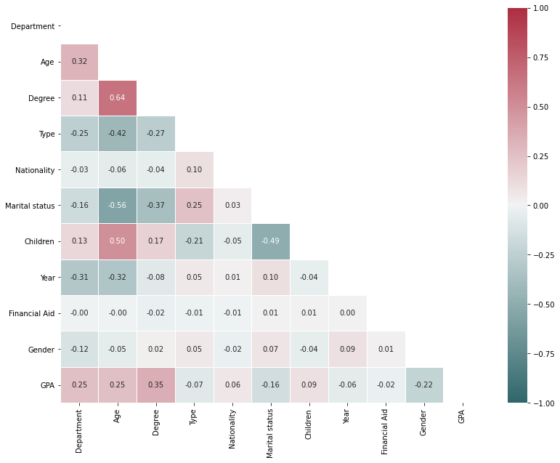

Figure 1: Correlation coefficients between variables

**c) Analytical findings**

*C-1) linear regression*

Linear regression is a commonly used statistical technique for modeling the relationship between a dependent variable and one or more independent variables. It is used to predict the value of the dependent variable based on the values of the independent ones. In linear regression, a linear relationship is assumed between the dependent variable and the independent variable(s), and the aim is to find the best-fitting line that minimizes the sum of the squared differences between the predicted values and the actual values. Linear regression can be used for both simple and multiple regression models. Simple linear regression involves one independent variable, while multiple linear regression involves two or more independent variables. In Figure 2, the most important variables in multiple linear regression are mentioned.

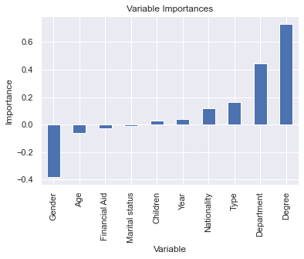

Figure 2: Importance of variables in multiple linear regression

In the following table, the results of applying multiple linear regression are mentioned.

Table 4: Results of applying multiple linear regression

|  |  |
| --- | --- |
| Value | Metrics |
| 1.290476995584436 | MAE |
| 2.694159658032994 | MSE |
| 1.6413895509698464 | RMSE |

The variable importance of all input variables is calculated and shown in fig. 2. Each independent variable had a coefficient which indicates the direction and magnitude of the relationship between the variable and the outcome. The degree has the highest positive feature importance with 73.04%, on the other hand Gender has the highest negative feature importance with -37.92%. Marital status with -1.23% importance, has the lowest effect on the log-odds of the outcome in this model. The average distance between the predicted values and the observed values are reported in regression metrics in table 4.

**C2) Neural network regression**

Neural networks (Kaur etal, 2016; Guo etal, 2015) are a type of machine learning algorithm that is inspired by the structure and function of the human brain. They are made up of interconnected nodes called neurons that collaborate to conduct complex computations. Neural networks are suitable for a wide range of applications, such as image and speech recognition, natural language processing, and autonomous control, due to their ability to recognize patterns and relationships in data. The ability to learn from data makes neural networks useful in situations where traditional rule-based systems would be impractical or impossible to implement. Neural networks can be trained using various algorithms, including backpropagation and stochastic gradient descent. The training process involves adjusting the weights and biases of the neurons in the network to reduce the difference between the predicted and the actual output. A reference for further reading on neural networks can be found in the book "Deep Learning" by Ian Good fellow. The neural network algorithm is shown in Figure (3).

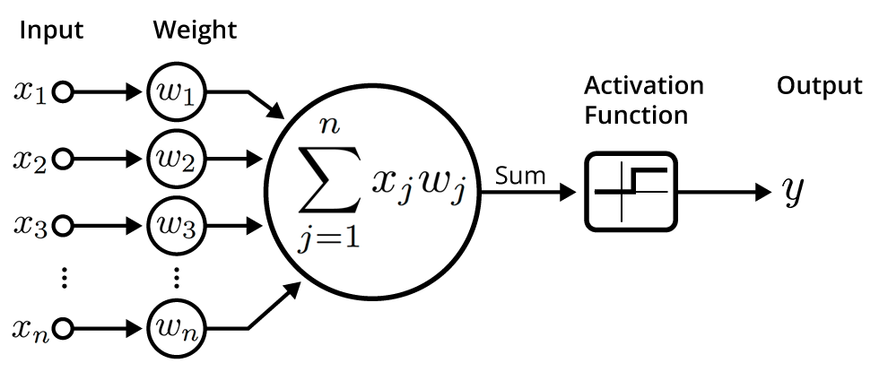

Figure 3: Neural network model with all the weights and activation function

The neural network structure used to predict GPA is summarized in table 5. The input layer receives the initial data, which is then propagated through two hidden layers with 16 neurons using the ReLU activation function. Finally, the forecast of the network is produced by the output layer. The total number of trainable parameters (weights and biases) in this structure is 465. Figure 4. shows how much the LOSS function changes. The loss function for the training data is in blue and the test data is orange. The downward trend in the difference between the predicted and actual values indicates the neural network model's increasing accuracy during each training period. The results of the application of neural network are listed in table 6.

Table 5: Neural network with two hidden layers including ReLU activation function. Adam optimizer is chosen to update the parameters of neural network during the 10 epochs training process.

|  |  |  |
| --- | --- | --- |
| Layer (type) | Output Shape | Number of Parameter |
| Hidden layer 1 | (None, 16) | 176 |
| Hidden layer 2 | (None, 16) | 272 |
| Output layer | (None, 1) | 17 |

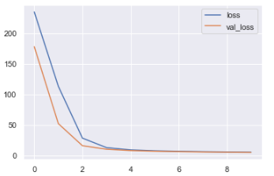

Figure 4: Loss function change during each training epoch

After two epochs the model predictions and actual values in training set have close values.

Table 6: The results of neural network regression application

|  |  |
| --- | --- |
| Value | Metrics |
| 1.6618198995049809 | MAE |
| 4.384664729322111 | MSE |
| 2.093959104023312 | RMSE |

**Hyperparameter optimization of neural network regression**

Neural network structure in this analysis is optimized via Keras hyperparameter tuning to have more precise prediction. Hyperparameter tuning is a critical step in building neural network models that involves selecting the optimal values for the hyperparameters. Hyperparameters are factors that are established before the training process begins, and they affect the behavior and performance of the neural network. Common hyperparameters that require tuning include the learning rate, number of hidden layers, number of neurons in each layer, activation function, and regularization strength. The optimal values for these hyperparameters depend on the specific problem, dataset, and architecture of the neural network. Grid search, random search, Bayesian optimization, and evolutionary algorithms are all methods for adjusting hyperparameters. These methods entail exploring the hyperparameter space in order to identify the optimal combination of hyperparameters that maximizes the neural network’s performance on a validation set.

Table 7 shows the optimized structure of the neural network. Based on the table, the neural network structure contains three intermediate layers with SELU activation function and 128 neurons. To prevent overfitting each hidden layer has a 10% drop rate. The change of Loss function in each training step for both the training set and testing set is shown in figure 5. The greater the complexity of the neural network, the lower the value for RMSE and other metrics, as described in table 8.

Table 7: The structure of neural network with three hidden layers. Each hidden layer is assigned 10% dropout rate to prevent overfitting. The kernel initializer and adam optimizer are used to initialize and update the weights of the neurons.

|  |  |  |
| --- | --- | --- |
| Layer (type) | Output Shape | Number of Parameter |
| Hidden layer 1 | (None, 128) | 1408 |
| Dropout later | (None, 128) | 0 |
| Hidden layer 2 | (None, 128) | 16512 |
| Dropout later | (None, 128) | 0 |
| Hidden layer 3 | (None, 128) | 16512 |
| Dropout later | (None, 128) | 0 |
| Output layer | (None, 1) | 129 |

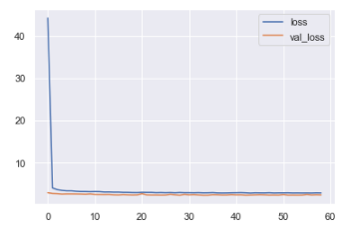

Figure 5: The Loss function undergoes changes that are indicative of the model’s learning process

The loss function starts with a relatively high values, while after some iteration it gradually decreases. No signature of overfitting is observed.

Table 8: Results of optimal neural network regression application

|  |  |
| --- | --- |
| Value | Metrics |
| 1.1981220878759695 | MAE |
| 2.4148747618820536 | MSE |
| 1.5539867315656377 | RMSE |

**C-3) Random Forest algorithm**

Random forests (Sorour & Mine, 2018) are a well-known machine learning algorithm for classification and regression tasks. They are an ensemble learning method that combines multiple decision trees to improve the accuracy and robustness of the model. In a random forest, multiple decision trees are trained on random subsets of the data and features. This randomization helps to minimize overfitting and improve the the model’s generalization ability. The final prediction is made by averaging the predictions of all the trees in the forest. Random forests are widely utilized in a variety of industries, including banking, healthcare and image analysis, where they have proven to be effective in handling high-dimensional data and dealing with missing or noisy data. A reference for further reading on random forests can be found in the paper "Random Forests" by Leo Breiman. Some key hyperparameters are tuned in order to improve the model’s performance, such as: number of decision trees to be included in the random forest, the maximum depth of each decision tree, the minimum number of samples required to be at a leaf node, controlling the bootstrap sampling in training for individual trees.

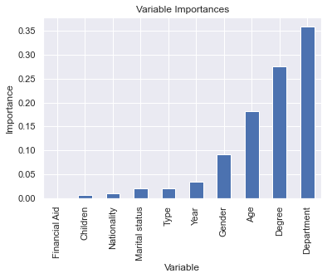

Figure 6: Importance of variables in random forest algorithm

In Figure 6, the importance of variables in the optimized random forest algorithm is shown. According to this figure, the department (where data is collected) and the level of education are the most relavent variables in learning the model with a high association. The model’s performance has improved and the values in table 9 represent the smaller difference between the predicted and the actual target values.

Table 9: The results of applying the random forest algorithm

|  |  |
| --- | --- |
| Value | Metrics |
| 1.1837001855958573 | MAE |
| 2.346364834468825 | MSE |
| 1.5317848525392934 | RMSE |

**C-4) Decision tree algorithm**

Decision trees (Pandey & Sharma, 2013) are a prominent machine-learning algorithm that is used for classification and regression tasks. They are a form of supervised learning algorithm that works by recursively partitioning the data into subsets depending on the input feature values, until a stopping criterion is met. In a decision tree, each internal node represents a test on a feature, each branch indicates the outcome of the test, and each leaf node represents a class label or a numerical value. Decision trees are extensively used in a variety of industries, including banking, healthcare, and image analysis, where they have proven to be effective when dealing with high-dimensional data and missing or noisy data.

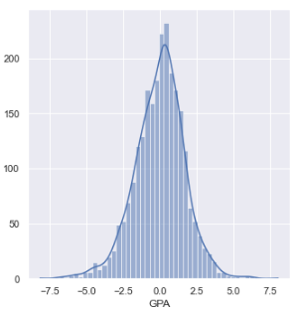

Figure 7: The graph of the difference between the predicted values and the actual values in the decision tree algorithm

Figure 7 shows the difference between the predicted and the actual values for the GPA variable. The accumulation of data close to zero implies that the model is highly accurate. Likewise, in terms of random forest feature importance, the department and degree features are the most relative in predicting the target variable (Figure 8). The performance of the decision tree is slightly weaker compared to random forest (considering simpler structure) while the normalized RMSE is still less than 20% as it is shown in table 10.

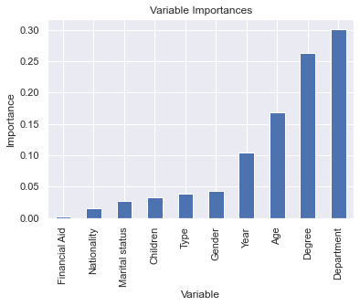

Figure 8: Importance of variables in decision tree algorithm

Table 10: The results of applying the decision tree algorithm

|  |  |
| --- | --- |
| Value | Metrics |
| 1.305568574702099 | MAE |
| 2.922975618633861 | MSE |
| 1.7096712019080924 | RMSE |

**D) Comparing the results of multiple linear regression model, neural network regression, random forest and decision tree**

The comparative comparison table states the MAE, MSE, and RMSE values for all implemented algorithms.

Table 11: Comparative comparison of supervised learning algorithms for predicting students' academic performance

|  |  |  |  |
| --- | --- | --- | --- |
| Algorithms | MAE | MSE | RMSE |
| Linear Regression | 1.290477 | 2.694160 | 1.641390 |
| Linear Regression regularized | 1.290571 | 2.694440 | 1.641475 |
| Neural Network | 1.661820 | 4.384665 | 2.093959 |
| Neural Network optimized | 1.198122 | 2.414875 | 1.553987 |
| Random Forest optimized | 1.183700 | 2.346365 | 1.531785 |
| Random Forest | 1.222495 | 2.455876 | 1.567124 |
| Decision Tree | 1.305569 | 2.922976 | 1.709671 |

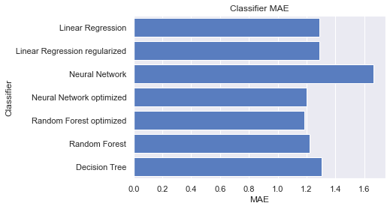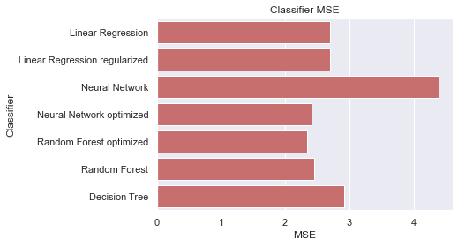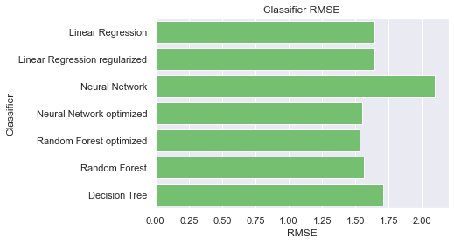

Figure 9: Comparison of implemented algorithms

**Discussion**

This research discussed the prediction of the GPA of Tehran University students based on artificial intelligence algorithms. Based on the implemented models, the optimized random forest model had the best RMSE with a value of 1.53. Predicting students' GPAs is critical because it is a key metric in evaluating students' academic performance. Because by analyzing students’ GPA status, it is possible to identify factors affecting it and to implement policies and solutions to improve students' academic performance. In this study, we predicted our model based on the findings of previous studies. Dabhade etal (2022) the best RMSE value was related to Support Vector with a value of 0.47. In another study, Çakt & Dağdeviren (2022), the best RMSE value was related to Extreme gradient boosting with a value of 3.01. In the research done by Beckham etal (2023) the best RMSE value was related to the Multi-Layer Perceptron with a value of 0.216. In another study by Dewi & Widiastuti (2020) the best RMSE value was related to SVR RBF with a value of 0.18.

The value of the normal RMSE in our research is 15%, which is more favorable than the studies conducted. The best RMSE value is related to the study of Dewi & Widiastuti (2020), which is 18%. As a result, our Predicting model is 3% more accurate in predicting. The first limitation of this research is the use of data recorded by students during registration (in the past). As a result, introducing additional variables other than the existing ones was impossible. The study's second issue is that in Iran, GPA is a continuous variable, while in most other countries, GPA is categorical. In addition, each country has its own educational structure, making it difficult to generalize the results. Furthermore, it is suggested that future researchers should use data from several universities in order to predict students' GPAs.

**References**

Abu-Naser, S. S., Zaqout, I. S., Abu Ghosh, M., Atallah, R. R., & Alajrami, E. (2015). Predicting student performance using artificial neural network: In the faculty of engineering and information technology.

Ahmad, F., Ismail, N. H., & Aziz, A. A. (2015). The prediction of students’ academic performance using classification data mining techniques. Applied mathematical sciences, 9(129), 6415-6426.

Al-Barrak, M. A., & Al-Razgan, M. (2016). Predicting students final GPA using decision trees: a case study. International journal of information and education technology, 6(7), 528.

Ali, N., Jusof, K., Ali, S., Mokhtar, N., & Salamat, A.S.A. (2009). THE FACTORS INFLUENCING STUDENTS’ PERFORMANCE AT UNIVERSITI TEKNOLOGI MARA KEDAH, MALAYSIA. Management Science and Engineering, 3(4), P 81-90

ALLAH, A. Q. G. F. (2019). Using machine learning to support students’ academic decisions (Doctoral dissertation, The British University in Dubai (BUiD)).

Altabrawee, H., Ali, O. A. J., & Ajmi, S. Q. (2019). Predicting students’ performance using machine learning techniques. JOURNAL OF UNIVERSITY OF BABYLON for pure and applied sciences, 27(1), 194-205.

Aluko, R. O., Adenuga, O. A., Kukoyi, P. O., Soyingbe, A. A., & Oyedeji, J. O. (2016). Predicting the academic success of architecture students by pre-enrolment requirement: Using machine-learning techniques. Construction Economics and Building, 16(4), 86-98.

Beckham, N. R., Akeh, L. J., Mitaart, G. N. P., & Moniaga, J. V. (2023). Determining factors that affect student performance using various machine learning methods. Procedia Computer Science, 216, 597-603.

Budiman, E., Haviluddin, Kridalaksana, A. H., Wati, M., & Purnawansyah. (2018). Performance of decision tree C4. 5 algorithm in student academic evaluation. In Computational Science and Technology: 4th ICCST 2017, Kuala Lumpur, Malaysia, 29–30 November, 2017 (pp. 380-389). Springer Singapore.

Çakıt, E., & Dağdeviren, M. (2022). Predicting the percentage of student placement: A comparative study of machine learning algorithms. Education and Information Technologies, 27(1), 997-1022.

Cheewaprakobkit, P. (2015). Predicting student academic achievement by using the decision tree and neural network techniques. Human Behavior, Development And Society, 12(2), 34-43.

Chuan, Y. Y., Husain, W., & Shahiri, A. M. (2017). An exploratory study on students’ performance classification using hybrid of decision tree and naïve Bayes approaches. In Advances in Information and Communication Technology: Proceedings of the International Conference, ICTA 2016 (pp. 142-152). Springer International Publishing.

Dabhade, P., Agarwal, R., Alameen, K. P., Fathima, A. T., Sridharan, R., & Gopakumar, G. (2021). Educational data mining for predicting students’ academic performance using machine learning algorithms. Materials Today: Proceedings, 47, 5260-5267.

Kaur, P., Singh, M., & Josan, G. S. (2015). Classification and prediction based data mining algorithms to predict slow learners in education sector. Procedia Computer Science, 57, 500-508.

Guo, B., Zhang, R., Xu, G., Shi, C., & Yang, L. (2015, July). Predicting students performance in educational data mining. In 2015 international symposium on educational technology (ISET) (pp. 125-128). IEEE.

Sorour, S. E., & Mine, T. (2016, July). Building an interpretable model of predicting student performance using comment data mining. In 2016 5th IIAI International Congress on Advanced Applied Informatics (IIAI-AAI) (pp. 285-291). IEEE.

Pandey, M., & Sharma, V. K. (2013). A decision tree algorithm pertaining to the student performance analysis and prediction. International Journal of Computer Applications, 61(13), 1-5.

Dewi, K. E., & Widiastuti, N. I. (2020, July). Support vector regression for GPA prediction. In IOP Conference Series: Materials Science and Engineering (Vol. 879, No. 1, p. 012112). IOP Publishing.

Falát, L., & Piscová, T. (2022). Predicting GPA of University Students with Supervised Regression Machine Learning Models. Applied Sciences, 12(17), 8403.

Gipson, J. A. (2018). Predicting Graduation and College GPA: A Multilevel Analysis Investigating the Contextual Effect of College Major (Doctoral dissertation, Purdue University).

Hamoud, A., Hashim, A. S., & Awadh, W. A. (2018). Predicting student performance in higher education institutions using decision tree analysis. International Journal of Interactive Multimedia and Artificial Intelligence, 5, 26-31.

Hussain, S., Dahan, N. A., Ba-Alwib, F. M., & Ribata, N. (2018). Educational data mining and analysis of students’ academic performance using WEKA. Indonesian Journal of Electrical Engineering and Computer Science, 9(2), 447-459.

Iqbal, Z., Qadir, J., Mian, A. N., & Kamiran, F. (2017). Machine learning based student grade prediction: A case study. arXiv preprint arXiv:1708.08744.

Kaunang, F. J., & Rotikan, R. (2018, October). Students' academic performance prediction using data mining. In 2018 Third International Conference on Informatics and Computing (ICIC) (pp. 1-5). IEEE.

Kesumawati, A., & Utari, D. T. (2018, October). Predicting patterns of student graduation rates using Naïve bayes classifier and support vector machine. In AIP conference proceedings (Vol. 2021, No. 1, p. 060005). AIP Publishing LLC.

Khan, F., Weiss, G. M., & Leeds, D. D. (2021). Predicting the Academic Performance of Undergraduate Computer Science Students Using Data Mining. In Advances in Software Engineering, Education, and e-Learning: Proceedings from FECS'20, FCS'20, SERP'20, and EEE'20 (pp. 303-317). Springer International Publishing.

Maulana, M. F., & Defriani, M. (2020). Logistic model tree and decision tree J48 algorithms for predicting the length of study period. PIKSEL: Penelitian Ilmu Komputer Sistem Embedded and Logic, 8(1), 39-48.

Mueen, A., Zafar, B., & Manzoor, U. (2016). Modeling and predicting students' academic performance using data mining techniques. International Journal of Modern Education and Computer Science, 8(11), 36.

Ngepah, N., Saba, C. S., & Mabindisa, N. G. (2021). Human capital and economic growth in South Africa: A cross-municipality panel data analysis. South African Journal of Economic and Management Sciences, 24(1), 11.

Phale, K., Fanglin, L., Adjei Mensah, I., Omari-Sasu, A. Y., & Musah, M. (2021). Knowledge-Based Economy Capacity Building for Developing Countries: A Panel Analysis in Southern African Development Community. Sustainability, 13(5), 2890.

Pojon, M. (2017). Using machine learning to predict student performance (Master's thesis).

Putpuek, N., Rojanaprasert, N., Atchariyachanvanich, K., & Thamrongthanyawong, T. (2018, June). Comparative study of prediction models for final GPA score: a case study of Rajabhat Rajanagarindra University. In 2018 IEEE/ACIS 17th International Conference on Computer and Information Science (ICIS) (pp. 92-97). IEEE.

Rehman, W., Degirmen, S., & Waseem, F. (2021). Propensity for and Quality of Intellectual Capital Divulgence Across the BRICS Banking Sector: A Knowledge-Based Perspective from Emerging Economies. Journal of the Knowledge Economy, 1-28.

Shamsi, M. S., & Lakshmi, J. (2016). A Comparative Analysis of classification data mining techniques: Deriving key factors useful for predicting students performance. arXiv preprint arXiv:1606.05735.

Singh, S. P., Malik, S., & Singh, P. (2016). Research paper factors affecting academic performance of students. Indian Journal of Research, 5(4), 176-178.

Sugiharti, E., Firmansyah, S., & Devi, F. R. (2017). Predictive evaluation of performance of computer science students of unnes using data mining based on naÏve bayes classifier (NBC) algorithm. Journal of Theoretical and Applied Information Technology, 95(4), 902.

Vijayalakshmi, V., & Venkatachalapathy, K. (2019). Comparison of predicting student’s performance using machine learning algorithms. International Journal of Intelligent Systems and Applications, 11(12), 34.

1. In this research, this variable is the number of children